EXPERIMENT-16
16. A wildlife information system determines whether an animal can fly based on its characteristics. Implement the Birds Fly Knowledge Base. Perform inheritance-based reasoning.

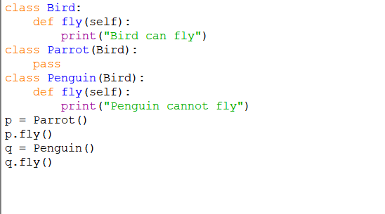
PROGRAM:

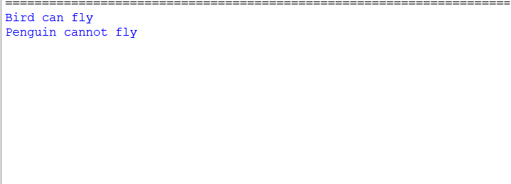
OUTPUT:

